Analyzing a picture
Learning Outcome : 2.3.2 Techniques and Elements – How various techniques and elements are used in oral, print and other media texts to accomplish particular purposes and create an overall impression.
Task: By referring to specific techniques or elements, analyze how your chosen visual conveys an idea or impression. Techniques and elements include: colour, contrast, detail, focal point, foreground/background, perspective, etc.
This type of question is on the provincial exam. When analyzing a picture, here are the different things to consider:
Colour | Context | Setting | People | Actions
Foreground | Background | Focus | Perspective | Angle
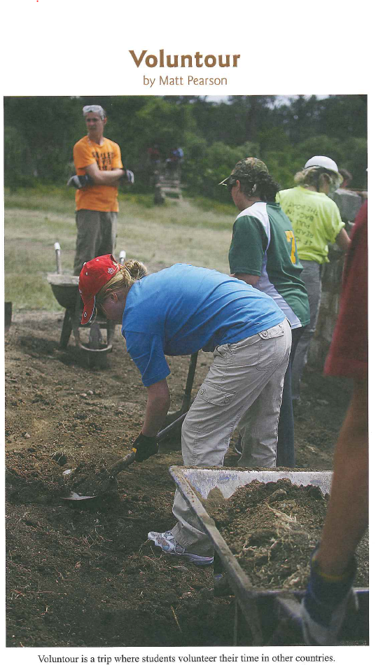
Here is an example of a picture to analyze :

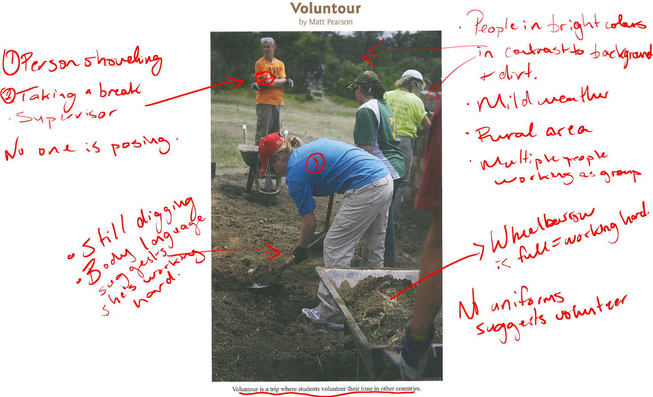
Step 1 : Analyze what you see on the picture (Similar to a talk to text)

Step 2 : From what you’ve identified in the picture, try to identify potential main ideas.
- Working as a team is more effective than working by yourself
- Everyone needs to play their part to help others in need
- Willingness to work to better our society
- Selflessness encourages positivity and can make our world a better place
- Be grateful for those who give back to help the community

Step 3 : Write a response in which this main idea is supported by the elements and techniques used in the picture and analyze the purpose of these techniques. Following this analysis, compare it to the society in which we live to show your understanding and your interpretation of the meaning behind the picture.

