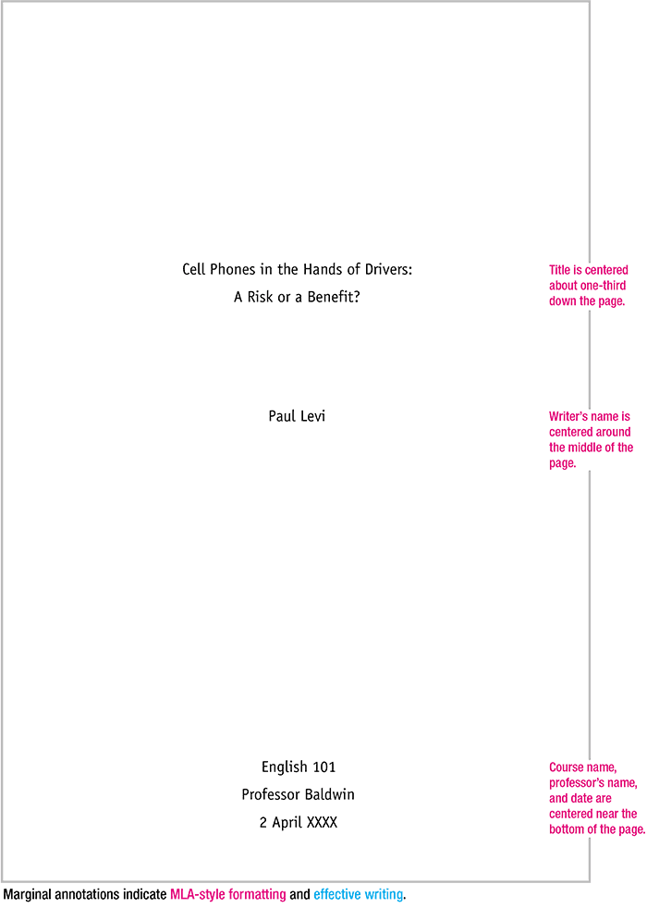

Awesome

Itsmaï Naym