Analytical essay writing - Structure
- A few simple rules
- Do not use I, we, you, our, your, etc. To stay objective, you need to be stay impersonal.
- Avoid rhetorical questions (“Is he an evil person? Well, yes he is” or “No, not at all” - repetition)
- Stick with facts or specific examples and explain them.
- Use quotes from credible sources in order to help develop your arguments and thesis.
- Numbers should be written with letters (ex: four instead of 4)
- Avoid popular language like “cause” “ok” “let’s say…” “hey” or “ya well…”
Structure of an introduction
1st part – opening – The opening has to attract the reader by making reference to an interesting event in our society (presently or historically). It also should be a reflection of the thesis without being specific to what will be presented in the essay.
2nd part – thesis statement – The thesis is the answer to the essay question. In other words, it is what someone is trying to prove throughout the whole essay.
3rd part – the arguments – To end the introduction, it is important to briefly present the arguments in order to anticipate how the thesis will be proven.
Example of an introduction
Evil has always occupied a somber position in society and damaging consequences have resulted from it. This unfavorable attribute has been associated to notorious individuals such as Satan or Adolf Hitler. For example, Hitler was an oppressive dictator who had a stranglehold on most of the German population and convinced them to carry out atrocious acts of violence such as killing innocent people. In Lord of the Flies, a novel by William Golding implicating two main characters who are competing for leadership and power, Jack is perceptibly the antagonist who represents this ghastly quality. The fact that he is a violent hunter, a ruthless leader, and that he is impervious to sympathy clearly demonstrates that he is the representation of evil.

Example of a conclusion
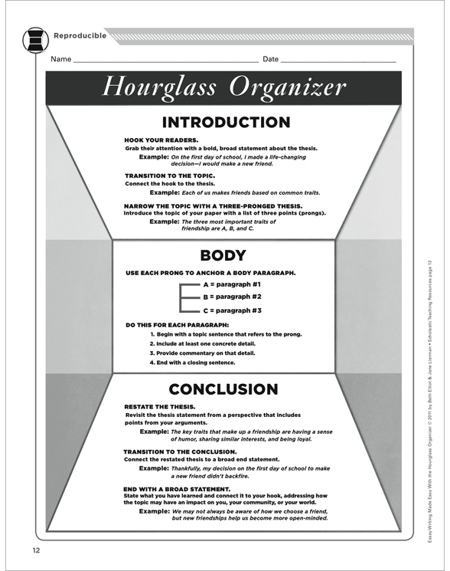
In retrospect, Jack has portrayed many dire qualities on the island which evidently makes him an evil person. The fact that he used intimidation to have control over others, that he was consumed with the idea of killing or that he took pleasure in humiliating people in order to feel more comfortable makes him abandon his conscience. Due to this behavior, it is impossible for him to be considered good. However, it might be argued that the boys’ isolation from adults which is an unusual event could be blamed for this situation. It could be contemplated that Jack might alter his personality once he returns to normal society and regenerate his morals.

